Step-by-Step:

Invoice Drop-Ship Purchased Finished Goods

| august-20 |

**Document Overview**

**Documentation Goals**

This documentation is intended to provide step by step instructions for ***Invoicing Drop-Shipped Purchased Finished Goods****.*

**Table of Contents**

**Invoice Drop-Ship Purchased Items** 2

Step One: Add an Order for all the Items 2

Step One: Open Order Maintenance Screen 2

Step Two: Add a New Order 3

Step Three: Enter Estimate 4

Step Four: Verify Order Information 5

Step Five: Save Order 5

Step Two: Place Purchase Order for the Items as Drop Ship 6

Add Purchase Orders 6

Print Purchase Orders 8

Step Three: Receive Finished Goods 10

Add Finished Goods Receipt 10

Post Finished Good Receipts 12

**System Control Parameters Set Up Process** 14

N-K-1 FGINVREC 14

Step One: Open System Control Parameters 14

Step Two: Find the FGINVREC Program 15

Step Three: View Current Parameters 16

N-K-1 OEAUTOFG 17

Step One: Open System Control Parameters 17

Step Two: Find the OEAUTOFG Program 18

Step Three: View Current Parameters 19

# **Invoice Drop-Ship Purchased Items**

## Step One: Add an Order for all the Items

### Step One: Open Order Maintenance Screen

The *Order Maintenance* screen is located in the following Menu Path: Order Processing -> Update/Add Orders -> Order Entry. Alternatively, the user can quickly get to this screen using the Hot Key combination: ***[“O” – “U” – “1”]***.

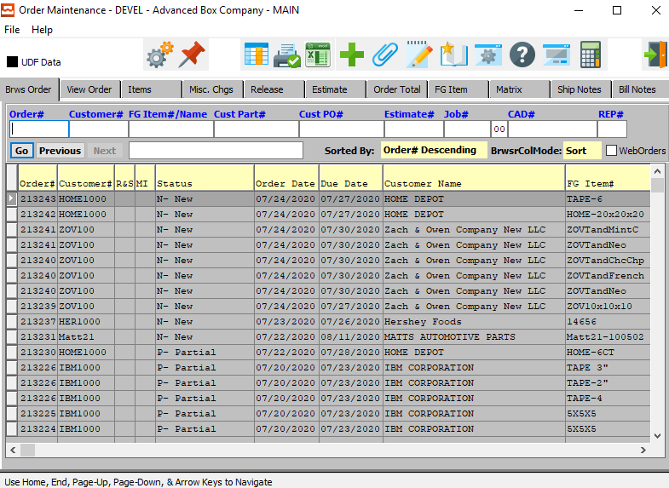

### Step Two: Add a New Order

To add a new order, the user can quickly press the ***“Green + Icon”*** at the top to the screen.



Alternatively, the user can move to the *View Order* tab, and click the ***“Add”*** button at the bottom of the screen.

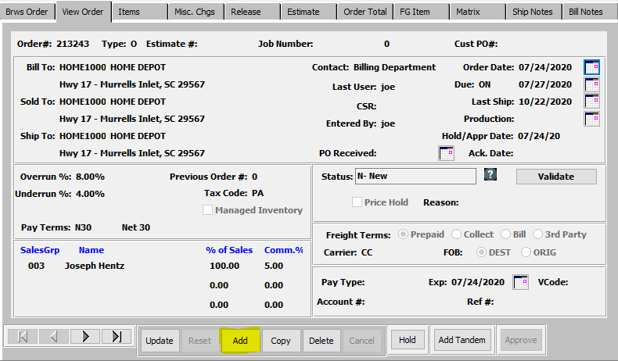

The new order will automatically be given an Order Number by the system, which is not modifiable by the user here.



### Step Three: Enter Estimate

The user must now enter an Estimate Number to base this new order on. If the user knows the Estimate Number that they wish to use, they may enter it manually in the *Estimate #* field.



Alternatively, the user can press the ***“F1”*** key to choose a number from a list of available Estimate Information.

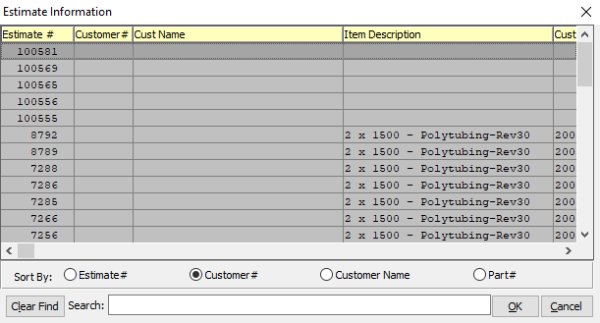

This list can be sorted by Estimate Number, Customer Number, Customer Name, or Part Number. Alternatively, the user may search for any estimate that they wish to use in order to narrow down their selection.

In order to choose the desired Estimate from this list, the user may double-click on the desired Estimate line. Alternatively, the user may click on their desired Estimate Line in order to highlight it within the list, then click the ***“OK”*** button at the bottom of the *Estimate Information* screen. Only a highlighted Estimate will populate within the new order.

### Step Four: Verify Order Information

Once the user has entered or chosen a valid Estimate Number, all of that Estimate’s relevant information will populate within the Order fields.

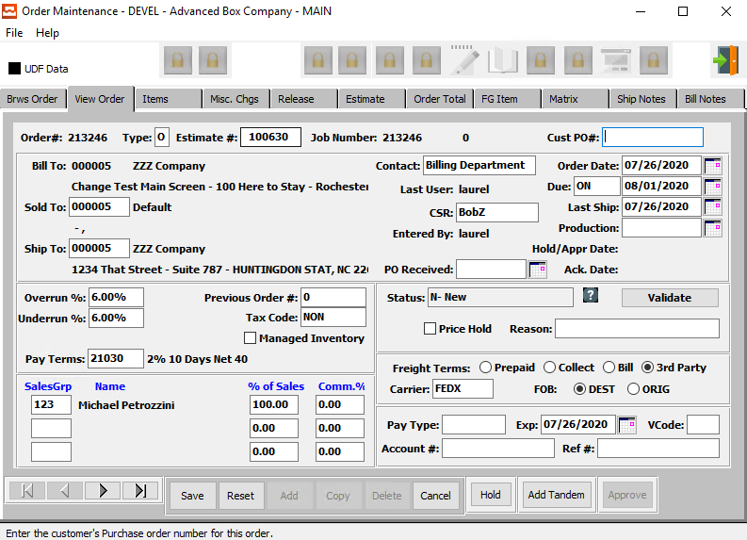

The user may now take this opportunity to update or change any available Order Fields. For any questions concerning specific Order Fields, the user may refer to the ***“Order Processing Manual”***.

### Step Five: Save Order

Once the user is satisfied with all of the information within this new order, they may click the ***“Save”*** button at the bottom of the screen to save the order to the system.



## Step Two: Place Purchase Order for the Items as Drop Ship

### Add Purchase Orders

#### Step One: Open Purchase Order Screen

The *Purchase Order* screen is located in the following Menu Path: Purchasing -> Update/Enter Purchase Order -> Enter/Edit PO’s. Alternatively, the user can quickly get to this screen using the Hot Key combination: ***[“P” – “U” – “1”]***.

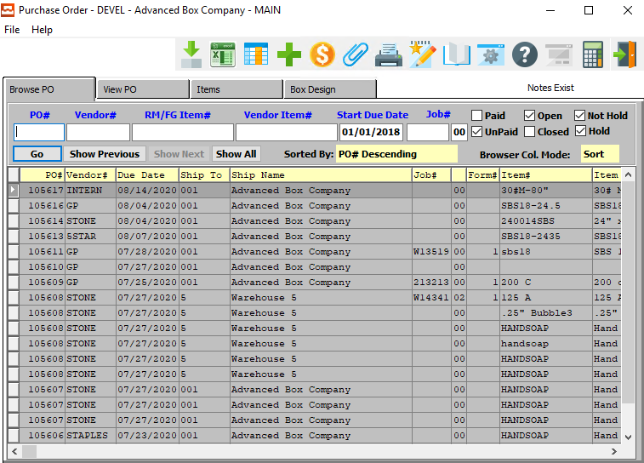

Purchase Orders may be added for Finished Goods for *Farm Out Jobs* or Raw Materials. The Raw Materials may be estimated or real-stocked raw goods. Ordering real materials requires creating unique items in the *Raw Materials File Maintenance* with actual width and lengths. Ordering estimated materials will not require creating unique items.

Please Note: Only real material will track a perpetual inventory. Estimated materials are purchased and consumed for a specific job. Once the job number is entered, the width, length and scoring allowance are transferred to the purchase order.

#### Step Two: Add a New Purchase Order

To add a new Purchase Order, the user can quickly press the ***“Green + Icon”*** at the top to the screen.



Alternatively, the user can move to the *View PO* tab, and click the ***“Add”*** button at the bottom of the screen.

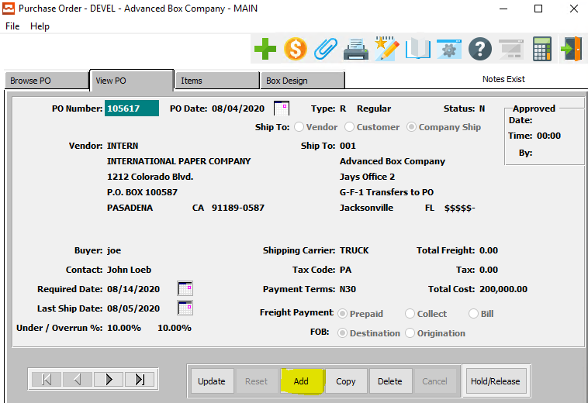

The new order will automatically be given an Order Number by the system, which is not modifiable by the user here.



#### Step Three: Review Purchase Order Information

The user may now take this opportunity to update or change any available Purchase Order Fields. For any questions concerning specific Purchase Order Fields, the user may refer to the ***“Purchasing Manual”***.

#### Step Four: Save Purchase Order

Once the user is satisfied with all of the information within this new purchase order, they may click the ***“Save”*** button at the bottom of the screen to save the purchase order to the system.



### Print Purchase Orders

#### Step One: Open Printing Screen

The *Print Purchase Orders* screen is located in the following Menu Path: Purchasing -> Update/Enter Purchase Orders -> Print PO’s. Alternatively, the user can quickly get to this screen using the Hot Key combination: ***[“P” – “U” – “3”]***.

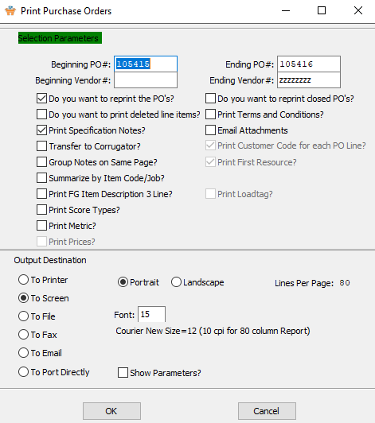

#### Step Two: Print Selected Purchase Orders

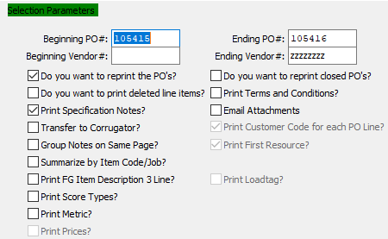

The user may now input their selection parameters as to which purchase orders they wish to print. Multiple purchase orders can be printed at the same time, as the user can enter the beginning and ending selections into their desired fields. Purchase Orders within those parameters will print tickets.

If the user is attempting to reprint Purchase Orders that have previously been printed, they must make sure that the *Do you want to reprint the PO’s* toggle box is checked.

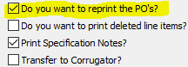

The user may now take this opportunity to check any toggle boxes for other special rules that they with the tickets to follow. For any questions concerning specific rules, the user may refer to the ***“Purchasing Manual”***.

#### Step Three: Send Board Orders to Corrugator

If the user is attempting to send Board Orders to a Corrugator, they must make sure that the *Transfer to Corrugator* toggle box is checked.

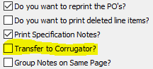

Please Note: The EDI field must be checked in the vendor file and the ***N-K-POEXPORT*** character value must be set to the appropriate corrugated scheduling software.

## Step Three: Receive Finished Goods

Receive Finished Goods and this will Automatically create an invoice.

### Add Finished Goods Receipt

*Finished Goods Receipts* are automatically created via the quantity posted during production on the last machine operation if the ***N-K-AUTOPOST*** flag is set to ***“Yes”***. For example, if the gluer is the last machine, the quantity posted on the gluer will update the receipts file. As an alternative, the receipts may be entered manually.

#### Step One: Open Finished Good Receipt Screen

The *Warehouse Transaction Receipt (Finished Goods)* screen is located in the following Menu Path: Inventory/Finished Goods -> Update Warehouse Transactions -> FG Enter/Modify Receipts. Alternatively, the user can quickly get to this screen using the Hot Key combination: ***[“I” – “U” – “1”]***.

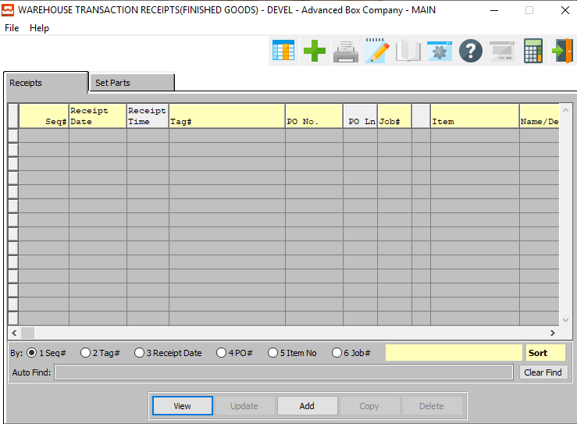

#### Step Two: Add a New Finished Good Receipt

To add a new receipt, the user can quickly press the ***“Green + Icon”*** at the top to the screen.



Alternatively, the user can click the ***“Add”*** button at the bottom of the screen.



#### Step Three: Verify Receipt Information

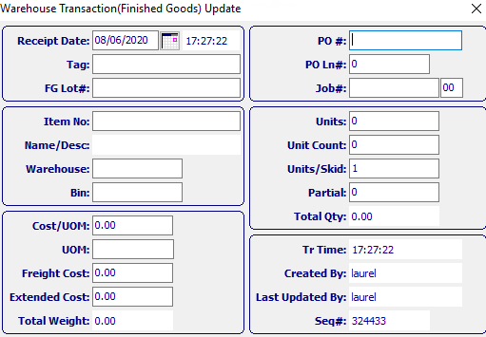

The user may now take this opportunity to update or change any available receipt Fields. For any questions concerning specific receipt Fields, the user may refer to the ***“Finished Goods Manual”***.

#### Step Four: Save Item

Once the user is satisfied with all of the information within this new receipt, they may click the ***“Floppy Disc Icon”*** button at the bottom of the screen to save the XXX to the system.



### Post Finished Good Receipts

*Finished Goods Receipt Transactions* must be posted so that the on-hand quantity is increased, the job quantity on order is decreased, and debits and credits to finished goods and work in process are posted.

#### Step One: Open Finished Goods Posting Screen

The *Finished Goods Posting* screen is located in the following Menu Path: Inventory/Finished Goods -> Update Warehouse Transactions -> Post to Finished Goods Files. Alternatively, the user can quickly get to this screen using the Hot Key combination: ***[“I” – “U” – “5”]***.

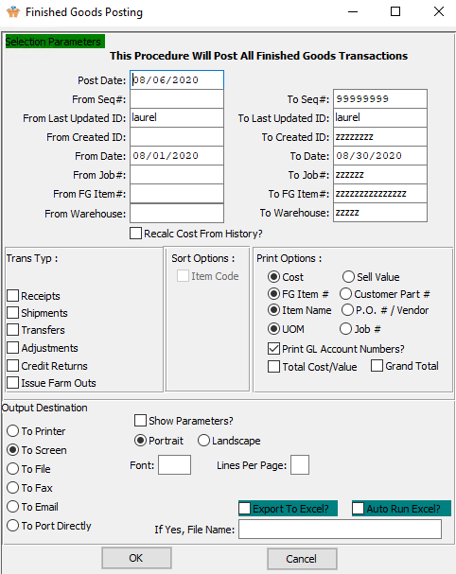

#### Step Two: Posted Selected XXX

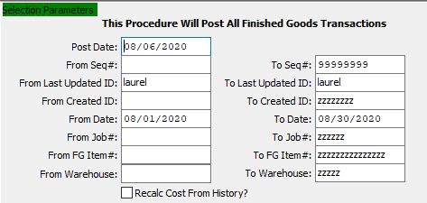

The user may now input their selection parameters as to which Finished Good Items that they wish to post. Multiple Finished Goods can be posted at the same time, as the user can enter the beginning and ending selections into their desired fields. Finished Goods within those parameters will post to the Finished Goods files.

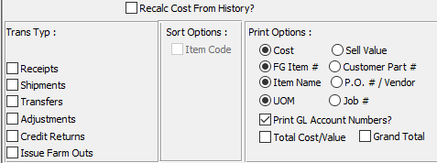

The user may now take this opportunity to check any toggle boxes for other special rules that they wish for the desired Finished Goods. For any questions concerning specific rules, the user may refer to the ***“Finished Goods Manual”***.

# **System Control Parameters Set Up Process**

Both of the following system control programs must be set to their proper parameters.

## N-K-1 FGINVREC

### Step One: Open System Control Parameters

The *System Control Parameters Maintenance* screen is located in the following Menu Path: Network/System Administrator -> K-Control Parameters -> System Control Parameters. Alternatively, the user can quickly get to this screen using the Hot Key combination: ***[“N” – “K” – “1”]***.

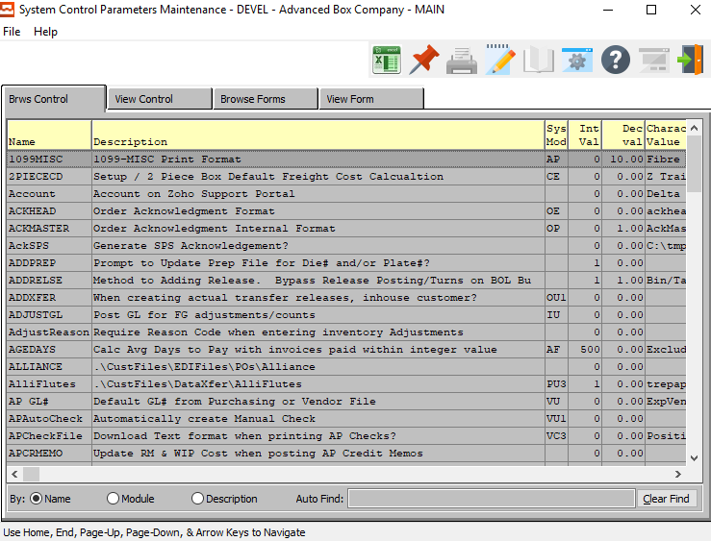

### Step Two: Find the FGINVREC Program

This *Browse Control* screen list can be sorted by Program Name, Module, or Description. Alternatively, the user may search for any Program that they wish to use in order to narrow down their selection.

In order to choose the desired Program from this list, the user may double-click on the desired XXX line. Alternatively, the user may click on their desired Program Line in order to highlight it within the list, then click the ***“View Control”*** tab at the top of the *System Control Parameters* screen. Only a highlighted program will populate within the View Control Detail Screen.

#### Search for FGINVREC

In this instance, the user is searching for the ***“FGINVREC”*** program.

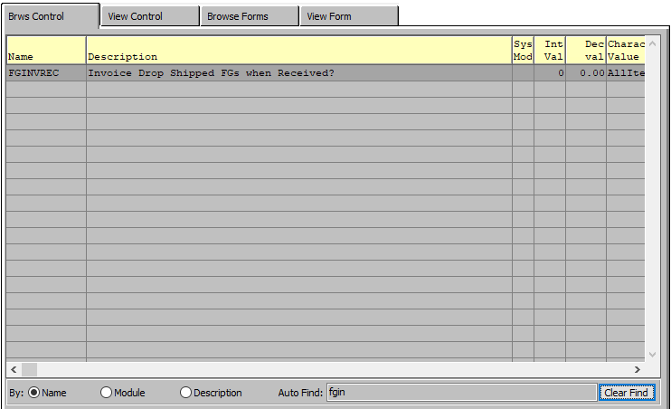

### Step Three: View Current Parameters

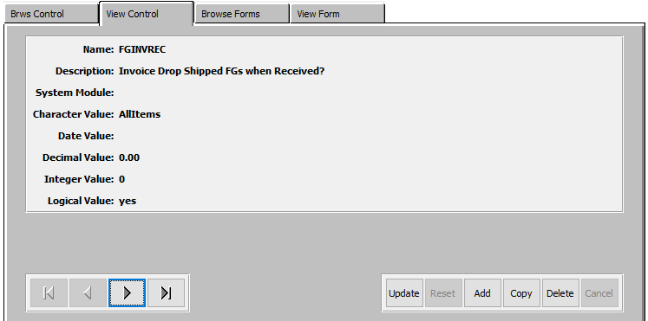

#### Logical Value

The ***Logical Value*** of this control program *must* be set to ***“Yes”***.

If it is not currently set to ***“Yes”***, the use may change the value using the ***“Update”*** button at the bottom of the screen.

When the logical value is “***Yes”***, finished goods posting will automatically create an Invoice for Finished Goods receipts via purchasing with a purchase order type of ***“D”*** for Drop Shipped. First a purchase order is created for a finished goods that is purchased as a drop shipment type purchase order. Hence the vendors on the purchase order will deliver the goods to the customer.

When the vendor notifies the box maker that the goods have been delivered, the finished goods receipt should be entered. The finished goods receipt will prompt "Create Invoice for Drop Shipped Purchase Order?

“***Yes”*** will flag the item during FG posting to automatically update the release quantity to the finished good receipt quantity, post the release and post the bill of lading, which will create the invoice. The bill of lading will have the same warehouse / bin location as the finished goods receipt.

## N-K-1 OEAUTOFG

### Step One: Open System Control Parameters

The *System Control Parameters Maintenance* screen is located in the following Menu Path: Network/System Administrator -> K-Control Parameters -> System Control Parameters. Alternatively, the user can quickly get to this screen using the Hot Key combination: ***[“N” – “K” – “1”]***.



### Step Two: Find the OEAUTOFG Program

This *Browse Control* screen list can be sorted by Program Name, Module, or Description. Alternatively, the user may search for any Program that they wish to use in order to narrow down their selection.

In order to choose the desired Program from this list, the user may double-click on the desired XXX line. Alternatively, the user may click on their desired Program Line in order to highlight it within the list, then click the ***“View Control”*** tab at the top of the *System Control Parameters* screen. Only a highlighted program will populate within the View Control Detail Screen.

#### Search for OEAUTOFG

In this instance, the user is searching for the ***“OEAUTOFG”*** program.

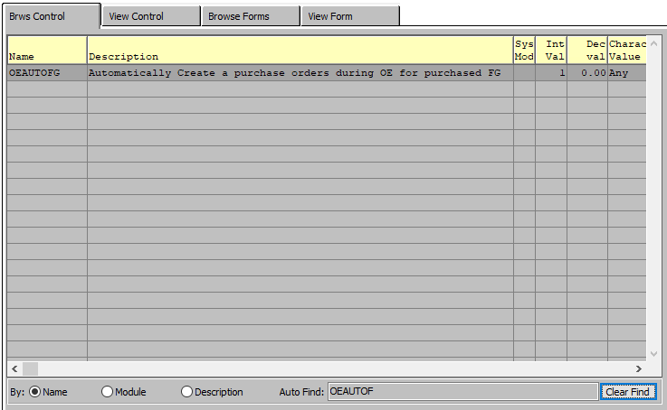

### Step Three: View Current Parameters

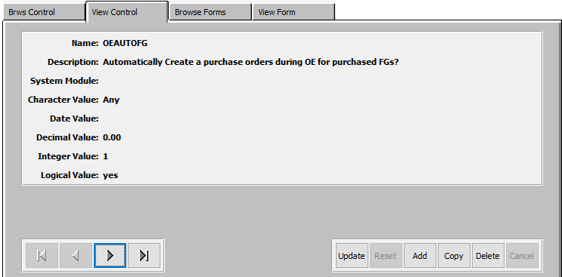

#### Character Value

The ***Character Value*** of this control program *must* be set to ***“Any”***.

If it is not currently set to ***“Any”***, the use may change the value using the ***“Update”*** button at the bottom of the screen.

The ***“Character Value”*** Dictates when to automatically create a purchase order for a finished good item. If the fields in the finished goods item file are defined as below.

Please Note” The purchased/manufactured field in the Finished Goods file must be set to Purchased. The character Value options are as follows: